SECTION 20 05 53 – piping and equipment identification
- GENERAL
      - RELATED DOCUMENTS
        - Drawings and general provisions of the Contract, including General and Supplementary Conditions and Division 01 Specification Sections, apply to this Section.
        - Specifications throughout all Divisions of the Project Manual are directly applicable to this Section, and this Section is directly applicable to them.
      - SUMMARY
        - Perform all Work required to provide and install Owner’s equipment tags, fire damper tags, valve tags, stencils, and pipe markers indicated by the Contract Documents with supplementary items necessary for proper installation.
        - Contractor shall make it possible for Owner’s personnel that will operate and maintain the equipment and systems in this Project to readily identify the various pieces of equipment, valves, piping, ductwork, fire dampers etc., by marking them in accordance with this Specification.
        - Clearly mark all items of equipment, including but not limited to, air handlers, fans, pumps, fire dampers, etc., using equipment tags as specified in this Section. The tagged item of equipment shall correspond to the same number as shown on the Drawings.
[Engineering Instruction: It is the Engineer’s responsibility to confirm all equipment numbers have been coordinated with the Owner’s Representatives. New equipment numbers shall not repeat existing equipment numbering in the field unless the equipment is being replaced and new equipment number will take place of old. Correct equipment identification shall be determined during design and confirmed before construction documents are complete. Having to change equipment numbers during construction due to lack of design coordination is unacceptable and will result in a negative report.]
      - REFERENCE STANDARDS
        - The latest published edition of a reference shall be applicable to this Project unless identified by a specific edition date or indicated otherwise by the Authority Having Jurisdiction or the Joint Commission/Center for Medicare and Medicaid Services
        - All reference amendments adopted prior to the effective date of this Contract shall be applicable to this Project.
        - All materials, installation and Workmanship shall comply with the applicable requirements and standards addressed within the following references:
          - ANSI A13.1 - Scheme for the Identification of Piping Systems.
          - NFPA 99 - 2012– Standard for Health Care Facilities.
          - NFPA 13 – Installation of Sprinkler Systems.
          - NFPA 14 – Installation of standpipe and Hose Systems.
          - Plumbing Code – per municipality in which facility is located.

      - SUBMITTALS
        - Product Data:
          - Provide manufacturer’s catalog literature for each product.
        - Record Documents:
          - Submit completed Equipment Matrix, Valve Schedule and Fire Damper Schedule before or at Project Closeout. Information shall be as shown in Attachments “A”, “B” and “C”. Submittals shall be in both paper copy and electronic file in Excel format. Excel Templates can be found online in the Manual of Practice, Volume 1, Chapter 1 – General Information, Design, Engineering Forms and Templates.
          - Equipment Matrix
            - Contractor shall submit a complete listing of all equipment, devices, and systems, with certain information as herein noted, within twenty-one (21) days of issuance of the Notice to Proceed with Construction and at least seven (7) days prior to submission of the first Application for Payment. This listing shall be referred to as the Equipment Matrix.
            - The Equipment Matrix shall be formatted as a spreadsheet. The Equipment Matrix shall be updated as the Project progresses and submitted periodically as requested by Owner. Provide Owner with an electronic version of the final approved Equipment Matrix at or before Project Close-out.
            - The Equipment Matrix shall identify all operable devices and equipment grouped by the Construction Specification Institute (CSI) Master Format under the system they are primarily categorized under. When sorted by the column for system identification, the resulting printout must identify all system components, regardless of whether they are mechanical, electrical, or otherwise.
            - Contractor shall continue to update the Equipment Matrix for each device or system. Owner will assist the Contractor in collecting information on Owner-furnished and Contractor-installed equipment.
          - Valve Schedule
            - Submit valve schedule complete with asset number, building number, room number, valve tag numbering system, valve function, valve type, area served, year installed, manufacturer, model number, size, rated pressure, temperature rating and normal position.
            - Valve schedule shall be developed utilizing Owner’s valve schedule template, refer to Attachment “A”. Provide Owner with electronic version (Microsoft Excel) of the final approved valve schedule at or before Project Closeout.
          - Fire Damper Schedule
            - Submit fire damper schedule complete with asset number, building number, room number, FD, FSD, SD equipment tag numbering system, system, function, damper type, area served, date installed, manufacturer, model number, damper size, temperature rating and damper blade type.
            - Fire damper schedule shall be developed utilizing Owner’s fire damper schedule template, refer to Attachment “E”. Provide Owner with electronic version (Microsoft Excel) of the final approved fire damper schedule at or before Project Closeout.
          - Operation and Maintenance Data:
            - Manufacturer’s Installation Instructions: Indicate special procedures and installation.
- PRODUCTS
      - GENERAL
        - All materials shall meet or exceed all applicable referenced standards, federal, state and local requirements, and conform to codes and ordinances of authorities having jurisdiction.
      - MANUFACTURERS
        - Equipment Tags, Valve Tags, and Markers:
          - Marking Systems, Inc.
          - Seton Name Plate Company.
          - W.H. Brady Company.
          - Graphic Products, Inc.
      - Equipment Tags
        - Description: Minimum 3” x 4” vinyl label, 3.0 Mil self-adhesive vinyl similar to DuraLabel Pro. Label color shall be black text on a white background. The label shall contain the following information:
          - Equipment name: Per Owner’s Equipment Naming Convention and as listed in Contractor’s Equipment List/Matrix.
          - Function
          - Area served
          - Asset number: per Equipment Asset Numbering Convention as confirmed by Facility Manager or as provided by Facility Manager.
          - All scheduled equipment shall be identified with an Equipment Tag.
      - VALVE tags
        - Valve tags shall conform to ANSI A13.1-1981 "Scheme for the Identification of Piping Systems". Refer to Attachment “D” for abbreviation and label color designations.
        - Valve tags shall be ABS plastic tags: Injected molded ABS plastic, 3.375” X 4.75” with self-adhesive vinyl label, similar to DuraLabel Pro, affixed to valve tag. Each tag shall be attached to its valve with one tie strap.
        - Vinyl Label: 3.0 Mil self-adhesive vinyl similar to DuraLabel Pro. Label color shall be as per the standard designated colors listed in Attachment “D” to this specification. The label shall contain the following information:
          - Valve name
          - System Served
          - Function
          - Area served
        - Each valve shall be named as per attached valve tag naming convention, refer to Attachment “E”.
        - In addition to valve tags, valves at water headers and steam PRV stations, valves associated with condensate, gas, water meters, and other valves as specified shall be tagged with standardized color coded plastic tags. Each tag shall be attached to its valve with one tie strap. These tags shall be 2-½ inches wide by 1-½ inches high with these color codings:
          - Red = normally closed.
          - Green = normally open.
          - Blue = open in winter, closed in summer.
          - Yellow = closed in winter, open in summer.
      - Pipe and duct markers
        - Round Pipe and Duct Markers shall conform to ANSI A13.1-2007 "Scheme for the Identification of Piping Systems", refer to Attachment “B” for abbreviation and label color designations. Arrow markers must have same ANSI background colors as their companion pipe markers, or be incorporated into the pipe identification marker.
        - Rectangular Duct Stencils shall conform to ANSI A13.1-2007 "Scheme for the Identification of Piping Systems", refer to Attachment “B” for abbreviation and label color designations. Letter height shall be a minimum of 1-1/4”. Stencil material shall be fiber board; Stencil paint shall be exterior, gloss, acrylic enamel. The following rectangular duct systems shall be stenciled:
          - Chemical Fume Hood Exhaust.
          - Biosafety Cabinet Exhaust.
          - Radioisotope Exhaust.
          - ETO Exhaust.
        - Plastic Pipe Markers: Factory fabricated, flexible, semi-rigid plastic, preformed to fit around pipe or pipe covering; minimum information indicating flow direction arrow and identification of fluid being conveyed.
        - Plastic Tape Pipe Markers: Heat sealed or heat shrink, spring fasteners, clips or snap-on, are acceptable.
        - Underground Plastic Pipe markers: Bright colored continuously printed plastic ribbon tape, minimum 6 inches wide by 4 mil thick, manufactured for direct burial service.
        - All medical gas piping shall have minimum information per NFPA 99, plus operating pressure.
        - Pipe markers and arrow markers also shall be provided for all piping systems.
        - Use Seton Setmark Type SNA or Brady snap-on type identification for all piping systems, up through 6 inch. For piping systems larger than 6 inches, use Seton or Brady strap-on markers or similar by Marking Services, Inc.
      - Ceiling Grid Tag For equipment LoCATED ABOVE Lay-in Ceiling
        - Description: 3/4” x 3” vinyl label, 3.0 Mil self-adhesive vinyl similar to DuraLabel Pro. Label color shall be black text on a white background. The label shall contain the following information per the template, described in Attachment “C”:
          - Equipment name: Per Owner’s Equipment Naming convention and as listed in Contractor’s Equipment List/Matrix.
          - Asset number: Number provided by Owner’s Representative upon request.
        - All scheduled equipment above finish lay-in ceiling shall be identified with an Equipment Tag.
- EXECUTION
      - INSTALLATION
        - Installation shall meet or exceed all applicable federal, state and local requirements, referenced standards and conform to codes and ordinances of authorities having jurisdiction.
        - All installation shall be in accordance with manufacturer’s published recommendations.
        - Install plastic tape, and pipe markers completely around pipe in accordance with manufacturer’s instructions.
        - Locate markers on the two (2) lower quarters of the pipe where view is unobstructed.
      - valve tags
        - Contractor(s) shall provide and install valve tags on all valves installed within this Project, except check valves; valves within fabricated equipment units; faucets; hose connections; needle valves; gauge cocks; HVAC terminal devices and similar roughing-in connections of end-use fixtures and units.
        - Existing valve tags shall not be attached to new valves. When removing and/or replacing existing tagged valves, give the Owner all existing tags that are attached to the valves that are removed. New tags with new asset numbers shall be provided for new valves.
      - Application of markerS aND sTENCILS
        - Piping runs throughout the Project including those above lift-out ceilings, under floor and those exposed to view when access doors or access panels are opened shall be identified by means of pipe markers and/or stencils. Concealed areas, for purposes of this identification section, are those areas that cannot be seen except by demolition of the building elements. In addition to pipe markers and/or stencils, arrow markers shall be used to indicate direction of flow.
        - As a minimum, locate pipe markers and/or stencils as follows:
          - Provide a pipe marker at each valve to indicate proper identification of pipe contents. Where several valves exist on one (1) header, it is necessary to mark only the header.
          - Every 20 feet in exposed and concealed areas on all piping systems. Provide at least one (1) pipe marker in each room on all piping systems.
          - At each branch or riser take off on piping systems, excluding short takeoffs for fixtures and terminal units.
          - Provide a pipe marker or stencil and an arrow marker at every point of pipe entry or exit where the pipe penetrates a wall, floor, service column or enclosure.
          - At access doors, manholes and similar access points that permit view of concealed piping.
          - Near major equipment items and other points of origination and termination.
          - Provide an arrow marker with each pipe marker pointing away from the pipe marker to indicate direction of flow.
          - Provide a double-ended arrow marker when flow can be in either or both directions.
          - Indicate delivered water temperature on domestic hot water supply and return lines.
          - Install underground plastic pipe markers 6 to 8 inches below finished grade, directly above buried pipe.
          - Identify control panels and major control components outside panels with plastic nameplates.
          - Identify valves in main and branch piping with tags.
          - Tag automatic controls, instruments and relays. Key to control schematic.
          - Provide ceiling grid tags to locate valves, fan coil units, dampers or other concealed equipment above T-bar type panel ceilings. Locate in corner of grid closest to equipment.
          - Identify pipe utilizing copper press fittings with markers stating, “Press-Fit” adjacent to each content identification marker.
          - Identify medium pressure gas piping (14 inches water column to 5psi) with the statement, “WARNING – ½ to 5psi NATURAL GAS”.
          - Identify right and left nipple and coupling union assemblies with the statement “Right/Left Nipple/Coupling”.

ATTACHMENTS:

“A” – Equipment Matrix
“B” – Valve Schedule
“C” – Fire, Fire/Smoke and Smoke Damper Schedule
“D” – Label Abbreviations, Background and Text colors
“E” – Valve tag naming convention
“F” – Equipment Identification Convention

END OF SECTION 20 05 53

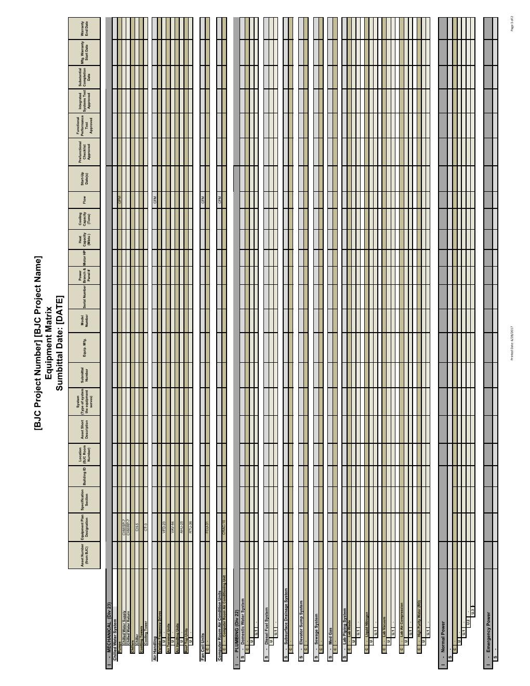

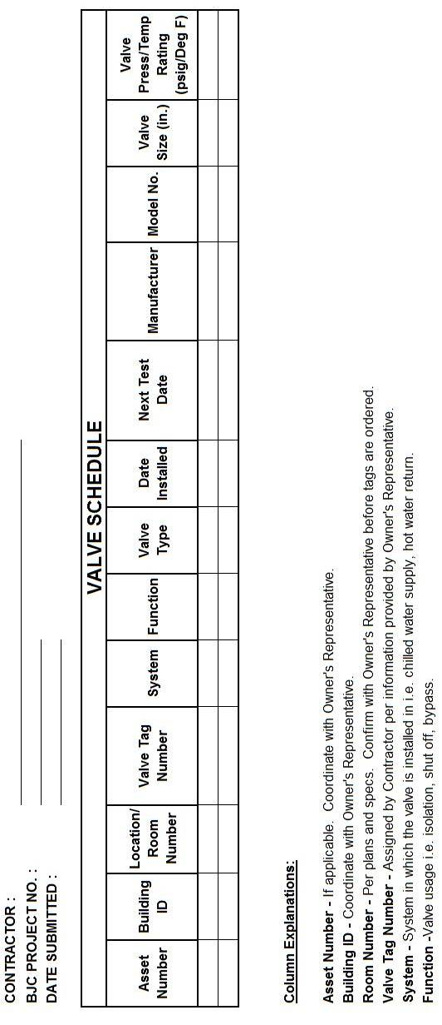

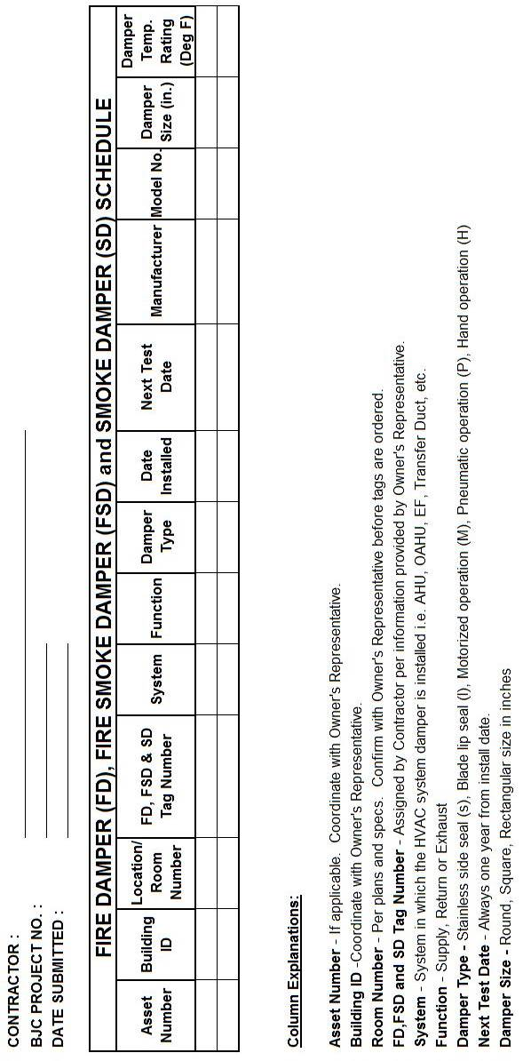

Mechanical/Plumbing Piping System Abbreviations and Letter/Label Coloring

Pipe Contents | Label Abbreviation | Label Colors (Background/Text)
Acid Waste | ACID | Orange/Black
Biosafety Cabinet Exhaust | BCE | Purple/white
Brine Water | BR | Orange/Black
Carbon dioxide | CO₂ | Gray/white
Chemical Fume Hood Exhaust | CFHE | Purple/white
Chilled Water Return | CHWR | Green/White
Chilled Water Supply | CHWS | Green/White
Condenser Water Return | CWR | Green/White
Condenser Water Supply | CWS | Green/White
ETO Exhaust | ETOE | Purple/white
Fire Suppression Water | FIRE | Red/White
Fuel Oil Return | FOR | Yellow/Black
Fuel Oil Supply | FOS | Yellow/Black
Gray Water | - | Green/White
Hazardous Waste | HAZ | Orange/Black
Helium | He | Brown/white
High Pressure Condensate | HPC | Blue/White
High Pressure Steam (above 125#) | HPS | Blue/White
High Purity Water | DI or RO | Green/White
Hot Water Heating Return | HWR | Green/White
Hot Water Heating Supply | HWS | Green/White
Instrument air | IA | Red/white
Laboratory air | Lab Air | Yellow and white checkerboard/black
Laboratory vacuum | Lab Vac | White and black checkerboard/black boxed
Low Pressure Condensate | LPC | Blue/White
Low Pressure Steam (below 25#) | LPS | Blue/White
Medical air | Med Air | Yellow/black
Medical–surgical vacuum | Med Vac | White/black
Medium Pressure Condensate | MPC | Blue/White
Medium Pressure Steam (above 25# - below 125#) | MPS | Blue/White
Natural Gas | NG | Yellow/Black
Nitrogen | N₂ | Black/white
Nitrogen (liquid) | LN2 | Black/White
Nitrous oxide | N₂O | Blue/white
Non-Potable Water | - | Green/White
Oxygen | O₂ | Green/white
Potable Cold Water | DCW | Green/White
Potable Hot Water Return | DHWR | Green/White
Potable Hot Water Supply | DHW | Green/White
Pumped Condensate Return | PCR | Blue/White
Radioisotope Exhaust | RE | Yellow/magenta
Waste anesthetic gas disposal | WAGD | Violet/white

[Engineering Instructions: Engineer is to confirm during design that this list is consistent with existing facility labeling convention. Inform Owner’s Representative if inconsistencies are found.]

Valve Tag Naming Convention

• The first set of characters are system type designators. (Number of letters will vary per system type)
X | X | X | X | X | - | X | X | X | X | - | X | X | X
  ⬆ ⬆ ⬆ ⬆ ⬆
System Type Abbreviation (See Attachment “B” for abbreviations)

• A dash shall separate each set of characters.
X | X | X | X | X | - | X | X | X | X | - | X | X | X
⬆
Placeholder

• The middle set of characters are the building designator.
X | X | X | X | X | - | X | X | X | X | - | X | X | X
   ⬆ ⬆ ⬆ ⬆
Building Designator (Contact Owner’s Representative)

• A dash shall separate each set of characters.
X | X | X | X | X | - | X | X | X | X | - | X | X | X
⬆
Placeholder

• The last set of characters are sequential valve tag numbers.
X | X | X | X | X | - | X | X | X | X | - | X | X | X
       ⬆ ⬆ ⬆
Sequential Valve Tag Number
(Number of digits will vary based on quantity of valves installed)

Below is an Example for a Chilled Water Supply Valve located in Christian Hospital Northeast POB1:

 | C | H | W | S | - | P | O | B | 1 | - | 9

NOTE: No two valve tags shall have the same name. Obtain valve tag names from Owner’s Representative when installing valves within existing system.

Equipment Identification Convention

• Equipment type designators. (Number of letters will vary)
X | X | X | X | X | - | X | X | X | X | - | X | X | X
  ⬆ ⬆ ⬆ ⬆ ⬆
Equipment Type Abbreviation

• A dash shall separate each set of characters.
X | X | X | X | X | - | X | X | X | X | - | X | X | X
⬆
Placeholder

• The middle set of characters are the building designator or number of floor.
X | X | X | X | X | - | X | X | X | X | - | X | X | X
   ⬆ ⬆ ⬆ ⬆
Building Designator (Contact Owner’s Representative)

• A dash shall separate each set of characters.
X | X | X | X | X | - | X | X | X | X | - | X | X | X
⬆
Placeholder

• Sequential equipment numbers unique from others already assigned in the building.
X | X | X | X | X | - | X | X | X | X | - | X | X | X
        ⬆ ⬆ ⬆
Sequential Equipment Number

Below is an Example for an AHU located in Christian Hospital Northeast POB1:

 | C | H | W | S | - | P | O | B | 1 | - | 9

[Engineering Note: Equipment designations shall not be duplicates of equipment already existing in the facility. It is the EOR’s responsibility to confirm unique equipment designators are assigned during the design process and coordinated with Owner’s Representatives.]

